Geometry Name: ___________________________

**HOMEWORK - Circle Vocabulary and Central Angles** Date: _______________­­­­_

*For problems 1 - 8, refer to circle symbolM.*

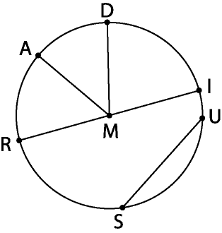

1. Name the center of the circle. ______
2. Name a chord that is also a diameter. ______
3. If MD = 5, find RI. _____
4. Is  a chord of *circle symbol*M? ____ What is it? _________
5. Is ? _____ Why? _______________
6. Name four radii of *circle symbol*M. ________________
7. If RI = 11.8, find MA. _______
8. Draw . What type of triangle is ΔMAR? _________ Explain. _______________

________________________________________________________________

*For problems 9 – 13, refer to circle symbolE. If m = 21˚ and  is a diameter,* ***determine whether each arc is a minor arc, major arc, or a semicircle****. Then,* ***find the degree measure*** *of each arc.*

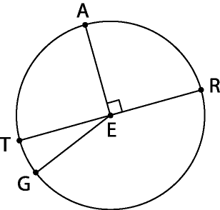 Minor, major, or semicircle Arc measure

**9.** TG __________________ ______

**10.** ATR __________________ ______

**11.** TAR __________________ ______

**12.** ARG __________________ ______

**13.** AR __________________ ______

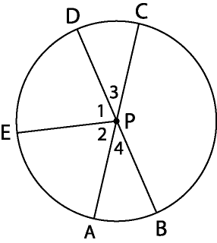In *circle symbol*P, m**1 = m**2*,* m**1 = 9x + 5, m**2 = 4x + 35 with diameters  and . Find each of the following.

**14.** x = _____ **15.** m**3 = _____

**16.** m**CPB = _____ **17.** m AE = _____

**18.** m EC = _____ **19.** m CBE = _____