**Geometry Name: ______________________________**

**Review for Quiz – Trig Ratios Date: ________________________**

1. Find the following:

  

2. If , find  and 

3. For any given right triangle, 

**Find the value of each. Round your answer to the nearest hundredth.**

4. sin 34o  5. cos 85o 6. tan 89o

**Write the trig equation and find the missing sides. Round answers to the nearest hundredth.**

7. 8. 9.

  

10. The sequoia redwood trees in California are some of the tallest trees in the world. If a person were standing 180 feet from one of these trees with a 60o angle of elevation to the top of the tree, what would be the height of the tree?

11. A passenger on a commercial flight from Augusta to Atlanta looks out his window and sees the city of Macon in the distance. If the angle of depression is 10o and the plane is flying at an altitude of 6 miles, what is the direct distance from the plane to the city of Macon?

12. A ladder leaning against a house makes an angle of 65o with the ground. The foot of the ladder is 7 feet from the foundation of the house. How long is the ladder?

13. The top of a lighthouse is 120 meters above sea level. The angle of depression from the top of the lighthouse to the ship is 23o. How far is the ship from the foot of the lighthouse?

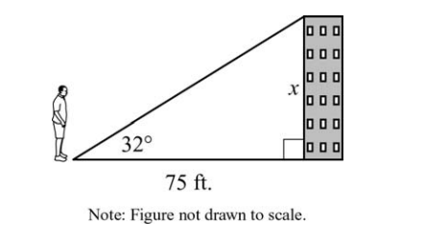14. Ricardo is standing 75 feet away from the base of a building. The angle of elevation from the ground where Ricardo is standing to the top of the building is 32o. What is x, the height of the building, to the nearest tenth of a foot?



15. What is the area of triangle RST? (A = ½ bh)

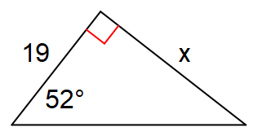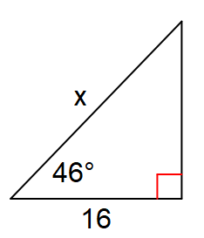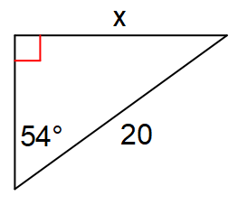Find the missing side. Round to the nearest tenth.

16. 17. 18.

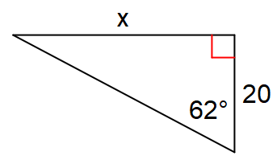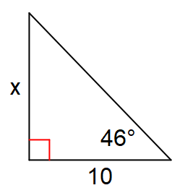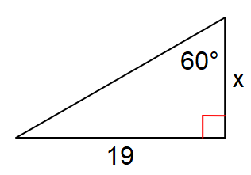

19. 20. 21.

Use co-functions to answer the following:  
22.  23.  24. 

25.  26.  27. 

28. In : m∠C = 90°. 