**Geometry Name: ______________________**

**Trigonometric Ratios (Day 2) – missing side Date: _________________**

WARM-UP – Numbers 1 – 11

1.  2. 

3. Find the exact value of the three trig functions for the triangle below.

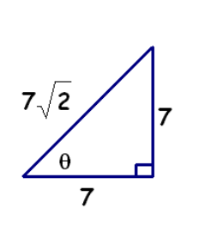

sin θ = cos θ = tan θ =

4. Sketch the triangle and find the other 2 trig functions of the acute angle.

A. cos  =  B. tan  = 6

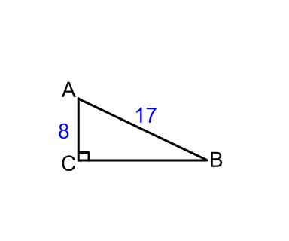5. Find the cosine and sine of the acute angles in the triangle shown.

The trigonometric function of the complement of an angle is called a _______________. Sine and cosine are cofunctions of each other.

Use co-functions to answer the following:

6.  7.  8. 

9.  10.  11. 

**Using the Calculator**

**You must always remember to check your calculator. It needs to be in ____________mode in order to calculate the answers correctly.

Let's make sure you can use your calculator. Round your answers to two decimal places.

sin 48o tan 22o cos 52o

**How would you solve these equations?**

sin 20o =  cos 80o = 

When given an acute angle measure and a side length, we can use trig to find another side length of the triangle.

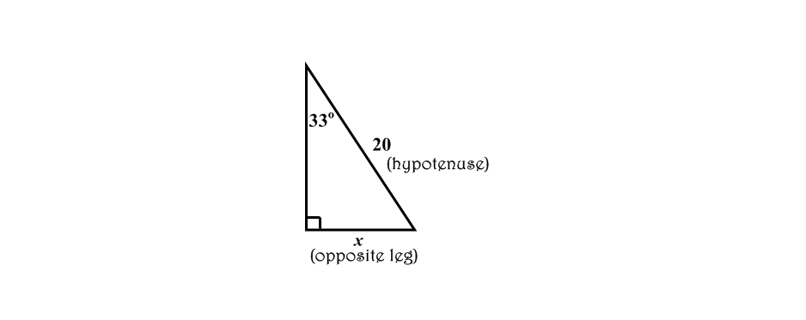

Which trig ratio contains "hypotenuse" and "opposite leg"?

Write an equation that would allow us to solve for x. Then, solve for x.

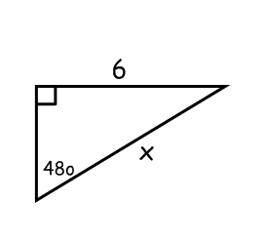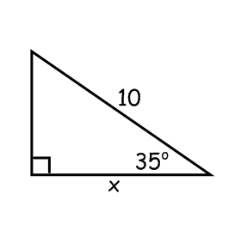Let's try another one. One More. . .

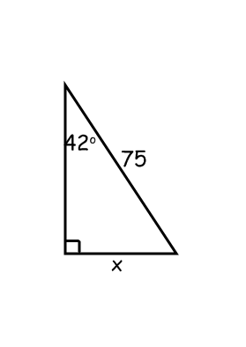

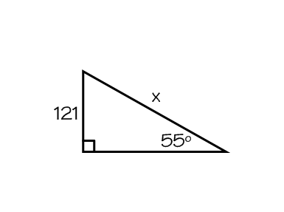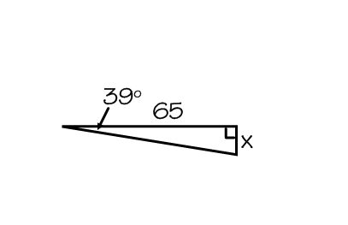Work with your neighbor on these problems.

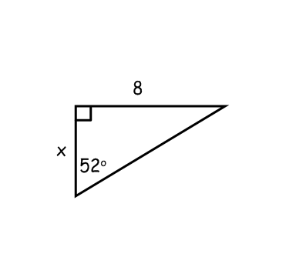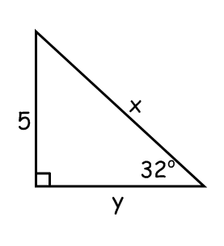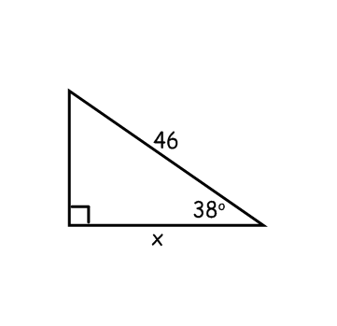 Find x and y.