**Geometry Name______________________**

**Classwork/homework – Trigonometric Ratios (Day 2) Date _________________**

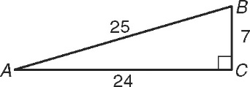Use the figure for Exercises 1–6. Write each trigonometric   
ratio as a simplified fraction.

1. sin A 2. cos B 3. tan B

4. sin B 5. cos A 6. tan A

**Sketch the triangle and find the other two trig functions of the acute angle.**

7.  8. 

**Complete each statement.**

9. The sin of 40o is equal to the ________ of 50o.

10. The sin of 25o divided by the cos of 25o is equal to the ______ of 25o.

11. The ________ of 10o is equal to the sin of 10o divided by the tan of 10o.

**Find the measure of each side indicated. Round the answers to the nearest hundredth.**



12.13.14.

15. 16. 17.



x