**Geometry Name: __________________________**

**Trigonometric Ratios & Cofunctions Date: _____________________**

**Triangle Sides (based on θ)**

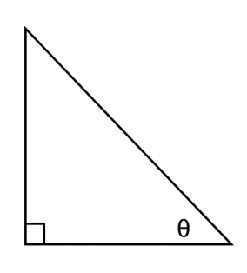

**_____________ ____________**

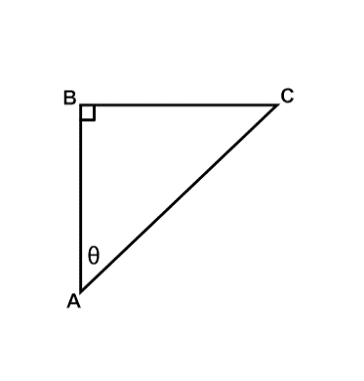

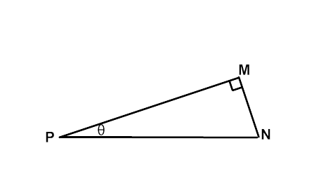

**____________________**

Which side is the hypotenuse? _________ Which side is the hypotenuse? _________

Which leg is opposite θ? ____________ Which leg is opposite θ? ____________

Which leg is adjacent to θ?__________ Which leg is adjacent to θ?__________

**What are the Trigonometric Ratios?**

|  |  |
| --- | --- |
|  |  |
|  |  |
|  |  |
|  |

**SohCahToa**

SOH _________________ equals _________________ over _________________

CAH _________________ equals _________________ over _________________

TOA _________________ equals _________________ over _________________

**How do we use these ratios?**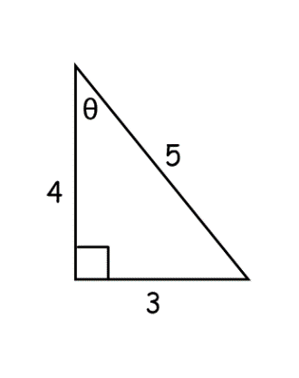

sin θ = ______ = ______

cos θ = ______ = ______

tan θ = ______ = ______

**Find the missing side and evaluate each for sin θ, cos θ, and tan θ.**

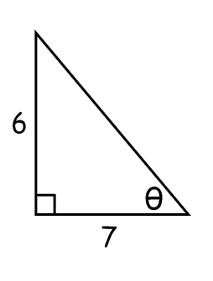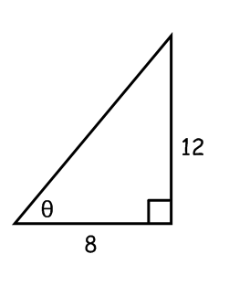

** **

**How would you solve the following problem?**

Suppose J and K are complementary angles in a right triangle. The value of tan J = .

What is the value of sin J?

1. Draw and label a triangle for the problem.

2. Use the given trig ratio to label the lengths of two sides. Then use the Pythagorean Theorem to find the third side.

3. Using the measures of the sides of the triangle, find sin J.

**Try this one...**

Suppose A and B are complementary angles in a right triangle. The value of sin A = .

What is the value of cos A?

**Trigonometry Co-Functions**

Let’s look at the relationship between our trig ratios.

* Start with a right triangle  where
* The acute angles will always be _________________________.
  + If 
  + If
  + If
* Let’s summarize:
  + 

For each of the following find the trigonometric ratio.





|  |  |  |
| --- | --- | --- |
| **Trigonometry Co-Functions** | | |
| **sin θ° =** | **cos θ° =** | **tan θ° =** |

Use co-functions to answer the following:

1. 
2. 
3. 
4. 
5. 
6. 
7. Is it ever possible that sin(x) = cos(x). Explain your reasoning.

Draw  where ∠B = 90° and .

1. What is the length of AB? _______________
2. What is cos C? _______________
3. What is sin A? _______________
4. In right : m∠C = 90°. .  
   1. 90 – m
   2. 45 – m
   3. 90 + m
   4. m
5. .  
   1. 40°
   2. 50°
   3. 60°
   4. 90°
6. .  
   1. 71°
   2. 35°
   3. 29°
   4. 19°
7. In : m∠C = 90°. . (There are 2 answers!)  
   1. sin(B)
   2. cos(B)
   3. cos(90-A)
   4. cos(90-B)
8. In : m∠C = 90°. .  
   1. 0.3
   2. 0.4
   3. 0.6
   4. 1.5