**Geometry Name: _________________________**

**Homework – Trigonometric Ratios Date:___________________________**

Find the length of segment RS and use the diagram to find the trigonometric ratios.

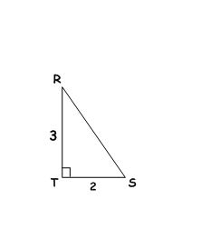1. sin R 4. sin S

2. cos R 5. cos S

3. tan R 6. tan S

7. What do you notice about the sin R and the cos S?

8. What do you notice about the cos R and the sin S?

9. What do you notice about the tan R and the tan S?

A and B are complementary angles in a right triangle. The value of sin A = .

10. What is the tan A?

11. What is the cos A?

M and N are complementary angles in a right triangle. The value of tan M = .

12. What is the sin M?

13. What is the cos M?

14. What is the sin N?

15. What is the cos N?

16. What is the tan N?