Geometry Name: ____________________________
TEST REVIEW – Transformations Date: _____________ Period: _________

Write the correct vocabulary word next to the definition.

1. _____________________ - an exact position or location in a given plane
2. _____________________ - part of a line bounded by two distinct endpoints
3. _____________________ - formed where two lines or rays share an endpoint
4. _____________________ - two coplanar lines that have unique points and never cross
5. _____________________ - a portion of a line that starts at a point and continues to infinity
6. _____________________ - creates four right angles
7. _____________________ - two angles whose sum is 90 degrees.

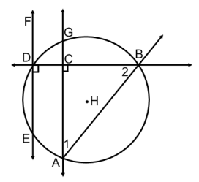
Find each geometry term in the diagram. Label using correct notation.

8. Ray: __________ 9. Circle: ___________

10. Line: ___________ 11. Line Segment: ___________

12. <1: ___________ 13. <2: ___________

Solve for x and find the measures of both angles.

14. <1 and <2 are supplementary. <1 = 8x – 14 and <2 = 2x + 54

15. <3 and <4 are congruent. <3 = 12x – 22 and <4 = 8x + 42

16. Use the translation (x, y) (x + 1, y - 7) for questions a – d.
a. What is the translation vector? __________
b. What is the image of A (10, -4)? __________
c. What is the image of A’ from part b (which would be called A”)? __________
d. What is the pre-image of C’ (-9, 12)? __________
17. What is an isometry? ____________________________________________________________
18. The vertices of $∆$ABC are A(-1. 0), B(5, 3), and C(2, -4). Find the vertices of $∆$A’B’C’ given the transformation rules below. Then describe the transformation that occurred.

- (x, y) (x + 11, y – 5) A’ = __________ , B’ = __________ , C’ = __________
Transformation: _____________________________
- (x, y) (-x, -y) A’ = __________ , B’ = __________ , C’ = __________
Transformation: _____________________________
- (x, y) (y, -x) A’ = __________ , B’ = __________ , C’ = __________
Transformation: _____________________________
- (x, y) (4x, 4y) A’ = __________ , B’ = __________ , C’ = __________
Transformation: _____________________________

- (x, y) (y, x) A’ = __________ , B’ = __________ , C’ = __________
Transformation: _____________________________
- (x, y) (-y, x) A’ = __________ , B’ = __________ , C’ = __________
Transformation: ____________________________

19. Answer the following questions.

- After a reflection over the line , (-2, 16) is the image of point C. What is the original location of point C?

- After a reflection over the x-axis, (8, 0) is the image of point M. What is the original location of point M?

- Given triangle FUN with coordinates F(-4, 1), U(11, -12) and N(-7, -9), find the image of point N after a rotation of 90 degrees counterclockwise.

- After a dilation with a scale factor of ½, (5, -4) is the image of point N. What is the original location of point N?

20. Write the transformation rule for the following graphs.

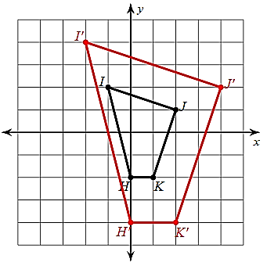
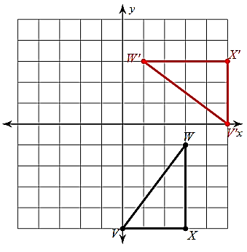
a. ____________________ b. ____________________ c. ____________________
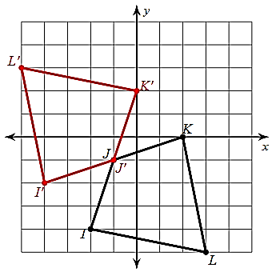

Follow the instructions for each graph.

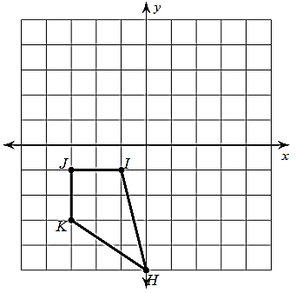
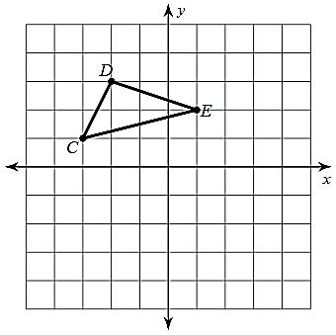
21. Reflection over x = 1 22. Rotation 90 degrees CW 23. Reflection over y = -x
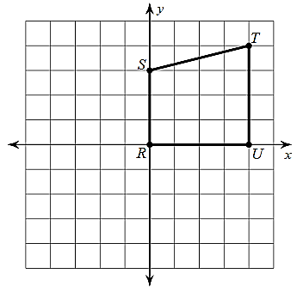

24. <2, 3> 25. (x, y) (x, y – 4 ) 26. (x, y) (0.5x, 0.5y)
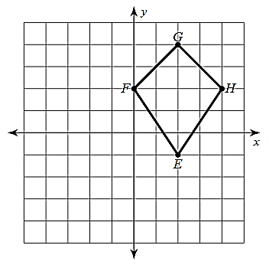
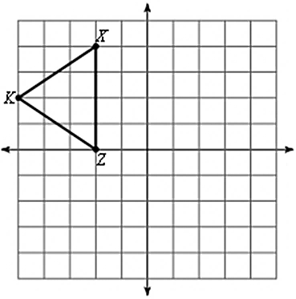
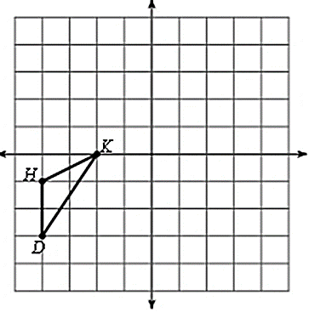

Composition of Transformations
(Label the first transformation with $∆$A’B’C’. After the second transformation, label it with $∆$A”B”C”.)

27. a. rotation 180 degrees 28. a. dilation of 2
b. reflection over y = -1 b. <1, -2>
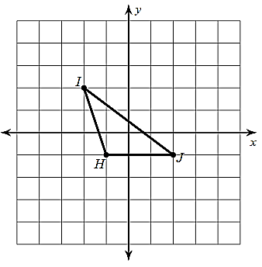
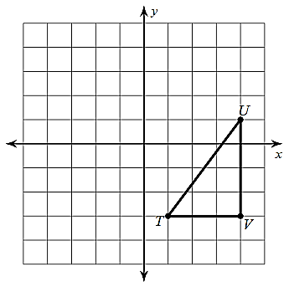

V’ ________ V” ________ H’ ________ H” ________
U’ ________ U” ________ I’ ________ I” ________
T’ ________ T” ________ J’ ________ J” ________

GOOD LUCK STUDYING!!!! Don’t forget to study your notes, your quiz, and this test review!!!

