Trig and Navigational Bearings
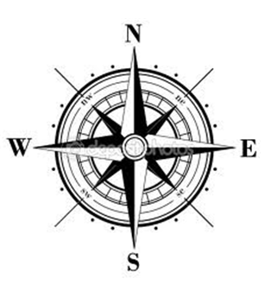
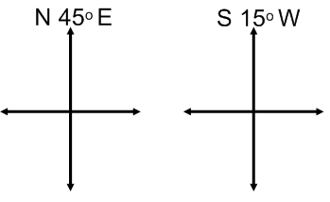
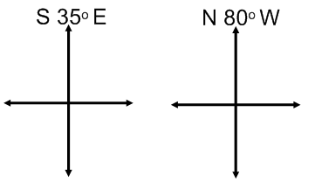

Right Triangle Applications with Bearings

Example 1: A ship leaves port at noon and has a bearing of S 29º W. If the ship sails at 20 knots, how many nautical miles south and how many nautical miles west will the ship have travelled by 6:00pm?

Example 2: A plane is 160 miles north and 85 miles east of an airport. If a pilot wants to fly directly to the airport, what bearings should be taken?

