**Geometry Name: _____________________________**

**Review for Unit 6 Test Date: ________________________**

1. In any right triangle, the sin 42º = cos_______ 2. In any right triangle, the cos ϴ = sin_______

3.  4.  5. 

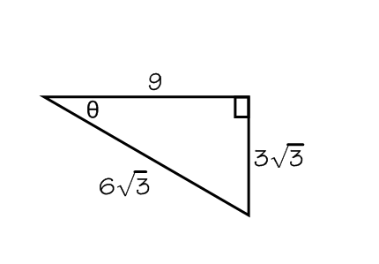6. In : m∠C = 90°. 

7. Find sine, cosine, and tangent of ϴ. 8. If the sinϴ=  find cosϴ and tanϴ.

sin ϴ= ________

cos ϴ= ________

cos ϴ= ________

tan ϴ= ________

tan ϴ= ________

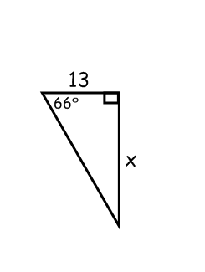

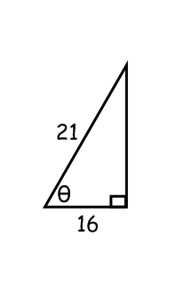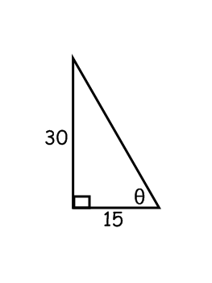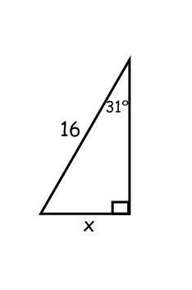

9. x = ________ 10. ϴ = ________ 11. x= ________ 12. ϴ= ________

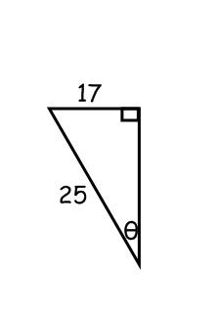

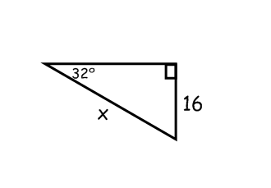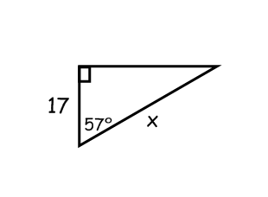13. 14. 15.

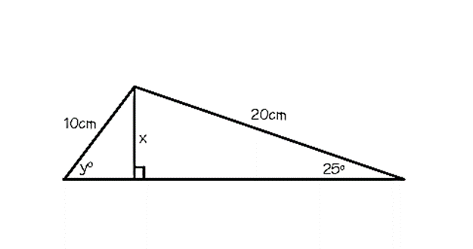ϴ= ________ x= ________ x= ________

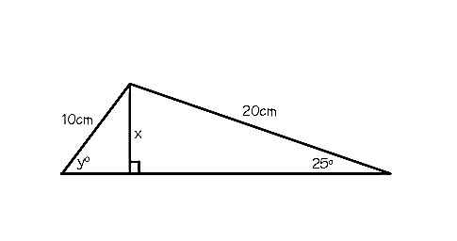16. Find the values of x and y. 

x = ________ y = ________

17. You are standing on the ground looking up at a bird’s nest in a tree. You estimate that you are standing 8 meters away from the base of the tree and the angle of elevation when you are looking up at the nest is 40o. Your eyes are about 1.6 meters off the ground. How high off the ground is the nest?

18. A slide 3.8 meters long makes an angle of 27o with the ground. How high is the top of the slide above the ground?

19. To illuminate the entrance of Pope High School, a spot light is mounted on a 39.5 foot pole. The base of the pole is 37.2 feet from the entrance. What is the angle of depression of the spot light?

20. A ramp is built to reach a doorway that is 9 feet off the ground. The ramp makes a 37o angle with the driveway. How long is the ramp?

21. A plane is coming in for a landing at the airport. If the airport is in a direct line of site 8000 ft. from the plane and the plane is at an altitude of 5000 ft., what is the angle of depression?

22. You are a block away from a skyscraper that is 780 feet tall. Your friend is between the skyscraper and yourself. The angle of elevation from your position to the top of the skyscraper is 42 o. The angle of elevation from your friend’s position to the top of the skyscraper is 71 o. To the nearest foot, how far are you from your friend?

23. A damsel is in distress and is being held captive in a tower. Her knight in shining armor is on the ground below with a ladder. When the knight stands 15 feet from the base of the tower and looks up at his precious damsel, the angle of elevation to her window is 60 degrees. How long does the ladder have to be in order to reach her?