**Geometry Name: __________________________**

**Solving Right Triangles (Angles) Date: _____________________**

When using trig functions, the goal is to find either a ________________ or an _________________.



To find a lengthTo find an angle

sin sin-1

__________ ___________ cos cos-1

tan tan-1

How do you use the calculator to find a

ratio of two lengths? 

How do you use the calculator to find an angle? 

**Calculator Practice**

**Round all lengths to the nearest hundredth (5.23 feet) and all angles to the nearest degree (470).**

   

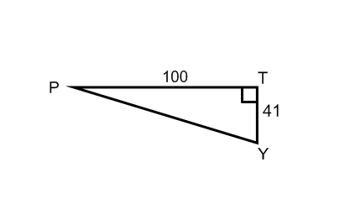

What is the measure of ? trig ratio

 calculator

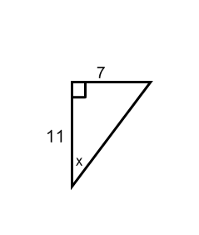

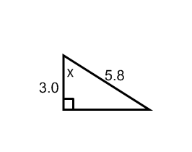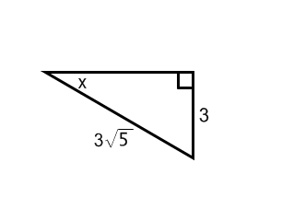

**Use trig functions to find the missing angle measures.**

1. 2. 3.

  