**Geometry Name: _______________________________**

**Radicals, Pyth. Thm., & Special Right Triangles Quiz Review Date: __________________________**

**PART I: Radicals**

1.  2.  3.  4. 

5.  6.  7.  8.   
  
  
  
  
  
  
  
9. 10.  11. 12.   
  
  
  
  
  
  
  
13. 14.  15.  16.  
  
  
  
  
  
  
  
17.  18.  19.  20. 

**PART II: Pythagorean Theorem**

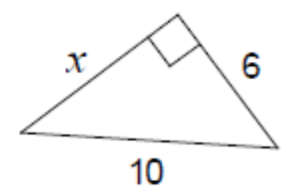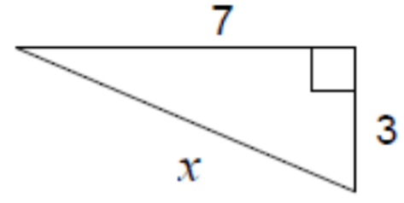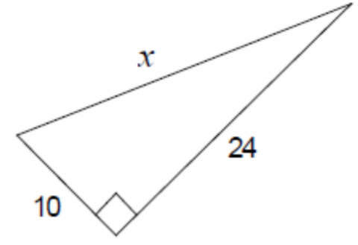1. 2. 3.

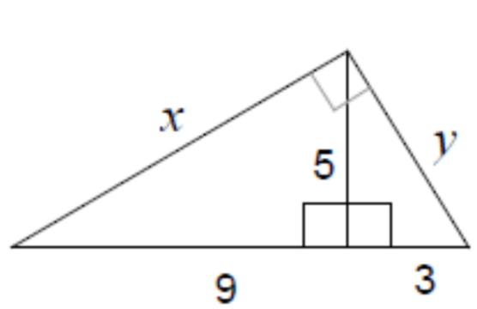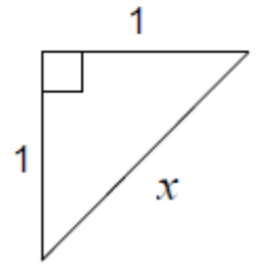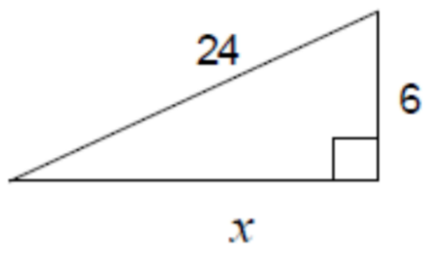

4. 5. 6.

For the following applications, make sure you draw a picture, show your work, and answer the question.

7. Two sides of a right triangle are 4 and 12 in.

a. Find the missing side if these are the lengths of the legs.

b. Find the missing side if these are the lengths of a leg and hypotenuse.

8. The foot of a ladder is placed 6 feet from a wall. If the top of the ladder rests 8 feet up on the wall, how long is the ladder?

9. John leaves school to go home. He walks 6 blocks North and then 8 blocks west. How far is John from the school?

10. A soccer field is a rectangle 90 meters wide and 120 meters long. The coach asks players to run from one corner to the corner diagonally across. What is this distance?

**PART III: Find the value of each variable in radical form.**

