Geometry Name: ___________________________

Special Right Triangles: 45-45-90 Date: __________

Warm-Up: Find the missing side lengths using your knowledge of 30-60-90 triangles.

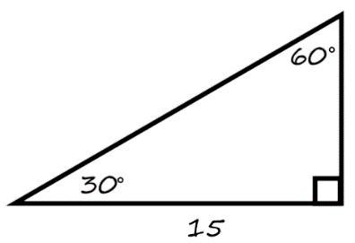

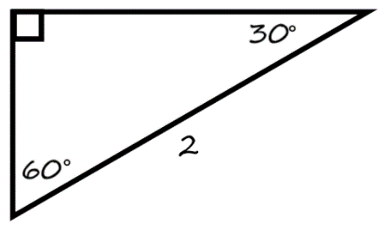1. 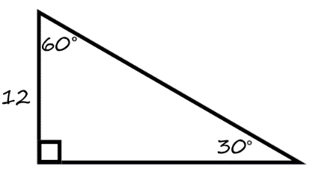 2. 3.

REMINDERS! Today we are focusing on 45-45-90 degree triangles!

**45o – 45o – 90o**  **30o – 60o – 90o**

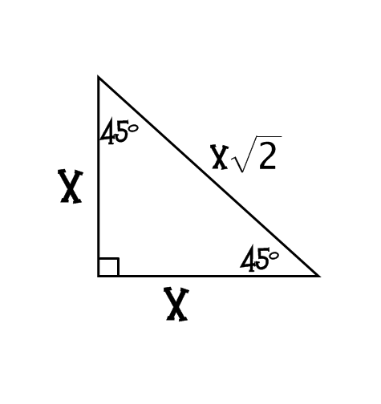

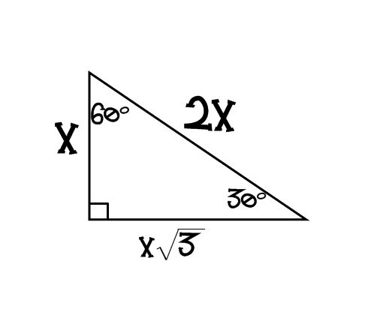

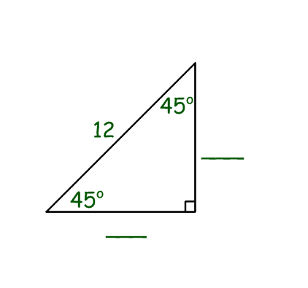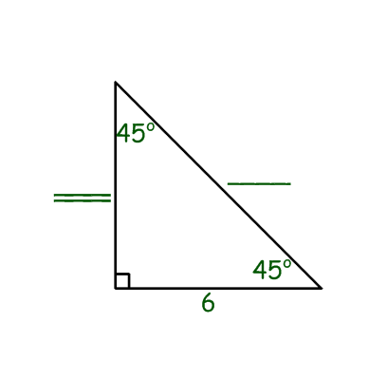

Examples

1. 2.

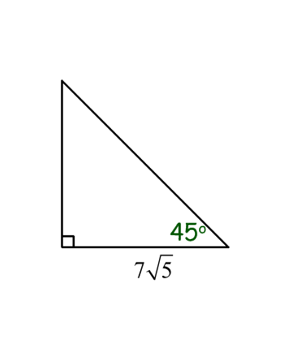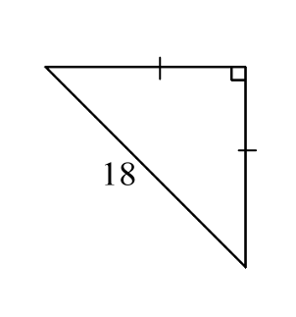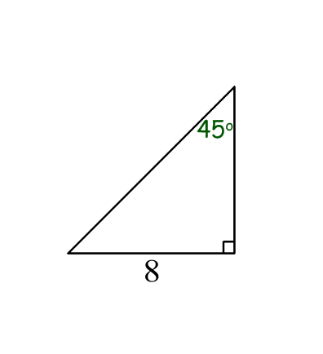

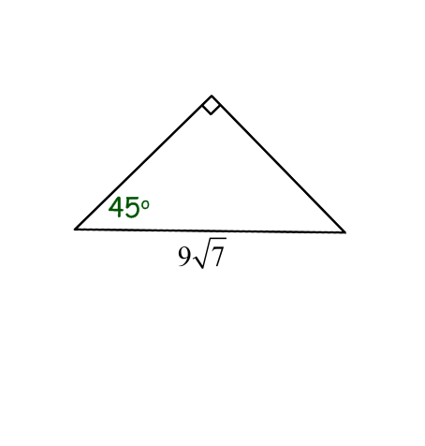3. 4. 5. 6.

Geometry Name_______________________

Classwork – Special Right Triangles Date __________________

|  |  |  |  |
| --- | --- | --- | --- |
| 1.  x  y  18  x  y  12  30° | 2. | 3.  x  y  30°  18 | 4.  x  y  45° |
| 5.  x  y  5 | 6.  x  y  15  30°  x  y  30° | 7.  x  y  60° | 8. |
| 9.  x  y  30°  12 | 10.    45°  y  x | 11.    60°  x  y | 12.  48  30°  x  y |
| 13.  14  30°  x  y | 14.  10  30°  x  y | 15. Equilateral Triangle  x | 16.  y  x  12  z  45°  30° |