Geometry Name: ________________________________
Pythagorean Theorem Date: _____________

PYTHAGOREAN THEOREM

Recall: Right Triangles
- The side of the right triangle that is the longest
and is always across from the right angle is
_________________ called the hypotenuse.

________ - The two shorter sides are called the legs of the
right triangle.

- Pythagorean Theorem: ______________________
__________ where “a” and “b” are legs and “c” is the hypotenuse.

Solve: x² = 9 x² = 10

Practice:
Find the missing side. Leave your answer in radical form.

1. 2.
5
7
8
6

3. 4.
5
4
10

13

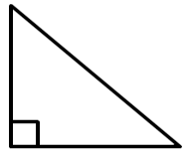
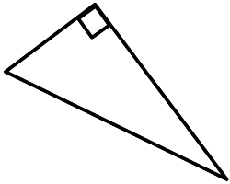
5. 6.
12 6 11

7

Application- Use the Pythagorean Theorem to solve these real world problems.

7. If the legs of an isosceles right triangle (2 sides are equal) are 6 units long, find the length of the hypotenuse.

8. A television screen measures approximately 15.5 in. high and 19.5 in. wide. A television is advertised by giving the approximate length of the diagonal of its screen. How should this television be advertised?

9. How far from the base of the house do you need to place a 15 foot ladder so that it exactly reaches the top of a 12 foot wall?

10. What is the length of the diagonal of a 10 cm by 15 cm rectangle?

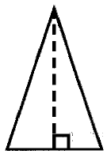
11. An isosceles triangle has congruent sides of 20 cm. The base is 10 cm. What is the height of the triangle? What is the area of the triangle? A = ½bh

12. Jill’s front door is 42 inches wide and 84 inches tall. She purchased a circular table that is 96 inches in diameter. Will the table fit through the front door?

