Geometry Name: _____________________________ (Study! ☺ )

Quiz Review – Congruency & Proofs Date: ___________________ Period: _________

1. Using the following image, find each missing angle measurement.

|  |  |  |
| --- | --- | --- |
| c  m  g  e  h  n  p  j  f  b  a |  |  |

2. Using the following figures, solve the needed values.

|  |  |
| --- | --- |
|  |  |
|  |  |
|  |  |
|  |  |

3. Using the Isosceles triangles, solve for the missing information.

|  |  |
| --- | --- |
|  |  |
|  |  |

4. State whether these triangles are congruent by SSS, SAS, ASA, AAS, HL, or none and **circle the answer**.

**Write a Congruence Statement if and only if the triangles are congruent.**

|  |  |
| --- | --- |
| SAS  SSS  ASA  AAS    HL    NONE  Statement:_____________________ | SAS  SSS  ASA  AAS  HL  NONE  Statement:_____________________ |
| SAS  SSS  ASA  AAS  HL  NONE  Statement:_____________________ | SAS  SSS  ASA  AAS  HL  NONE    Statement:_____________________ |

ALGEBRAIC PROOFS. Fill in the missing information for each algebraic proof.

5. Given: 6 = 10 – 2x + 8 6. Given: 5x + 34 = -2(1 – 7x)

Prove: x = 6 Prove: x = 4

|  |  |
| --- | --- |
| **STATEMENT** | **REASON** |
| 6 = 10 – 2x + 8 |  |
| 6 = 18 – 2x |  |
| -12 = -2x |  |
| 6 = x |  |
| x = 6 |  |

|  |  |
| --- | --- |
| **STATEMENT** | **REASON** |
| 5x + 34 = -2(1 – 7x) |  |
| 5x + 34 = -2 + 14x |  |
| 34 = -2 + 9x |  |
| 36 = 9x |  |
| 4 = x |  |
| x = 4 |  |

7. Given: -8(6 + 5x) + 5 = 3x 8. Given: 8x + 12 = 9 + 5x

|  |  |
| --- | --- |
| **STATEMENT** | **REASON** |
|  |  |
|  |  |
|  |  |
|  |  |

Prove: x = 6 Prove: x = -1

|  |  |
| --- | --- |
| **STATEMENT** | **REASON** |
|  |  |
|  |  |
|  |  |
|  |  |
|  |  |
|  |  |

9. If , then:

a.  ________ b. ________ c. ________

d. ________ e.  ________ f.  ________

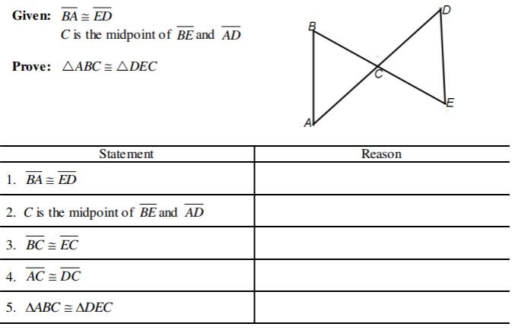10.

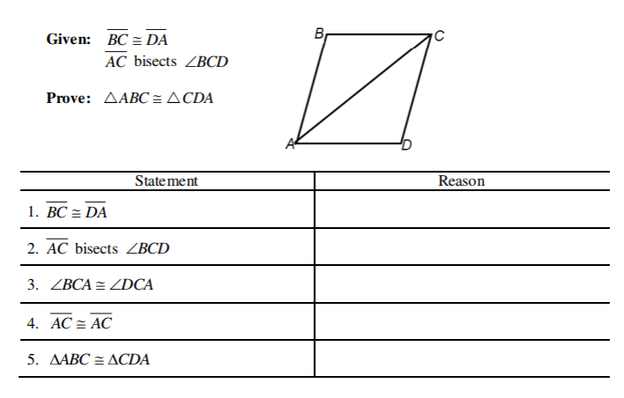

11.

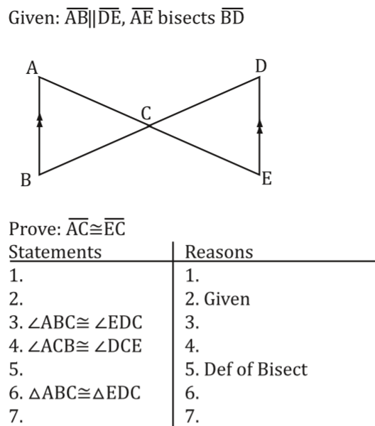

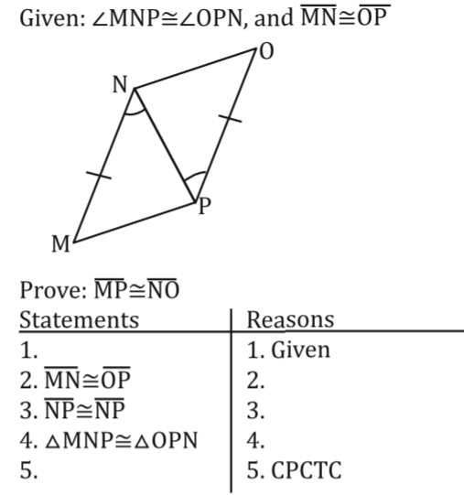  
12. 13.