Geometry Name: ________________________
Special Right Triangles Applications Practice Date: ____________

1. Find the length of a diagonal of a square with sides 10 in. long.

2. The area of a square is 10 cm². What is the product of the lengths of the diagonals of the square?

3. One side of an equilateral triangle measures 6 cm. Find the measure of an altitude of the triangle.

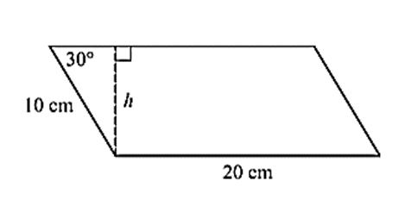
4. A parallelogram has sides that are 10 cm and 20 cm long. The measure of one of the acute angles of the parallelogram is 30º. What is the area of the parallelogram?
(area = base * height)

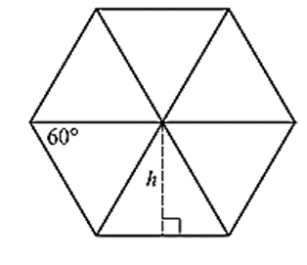
5. What is the area of a regular hexagon with sides that are 10 units long?
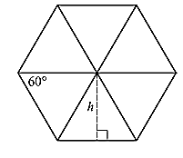

6. What is the side length of a square that has a diagonal length of 12 inches?

7. What is the perimeter of an equilateral triangle that has a height of 18 cm?

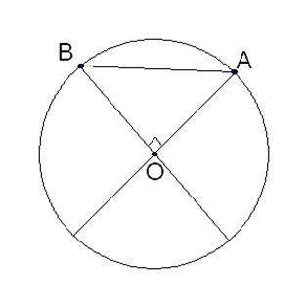

8. If segment AB has a length of 20, what is the radius of the circle with center O?

