**Warm-Up: Radicals**

**How do you multiply radicals? Leave in radical form unless it is a perfect square!**

1.  2.  3.  4.  5. 

**How do you divide radicals? Leave in radical form unless it is a perfect square! Remember you cannot have a radical in the denominator! ☺**

11.  12.  13.  14.  15. 

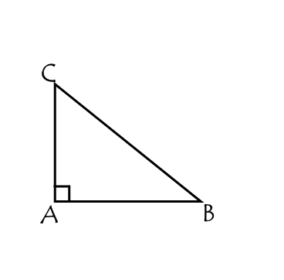**Right Triangles**

The side opposite the right angle is called the ________________________.

Which side is this in ? __________

The other two sides of a right triangle are called _______________.

Which sides are these in ? _________________

The legs are often referred to as **opposite sides**.

Which side is opposite in ? __________

Which side is opposite in ? __________

Each of the non-right angles in a right triangle is an acute angle.

What is true about the acute angles of a right triangle? ______________________

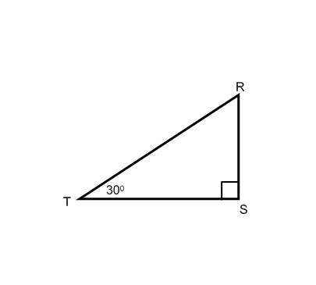**Practice with terminology and angle measures…**

1. Find the. ________

2. Name the side opposite . ________

3. Name the side opposite . ________

4. Name the hypotenuse. ________

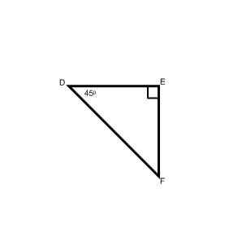5. Find the. ________

6. What kind of triangle is ? ________

7. Name the side opposite . ________

8. Name the side opposite . ________

9. Name the hypotenuse. ________

**SPECIAL RIGHT TRIANGLES**

There are two types of special right triangles: __________________ & ____________________.

**45o – 45o – 90o**  **30o – 60o – 90o**

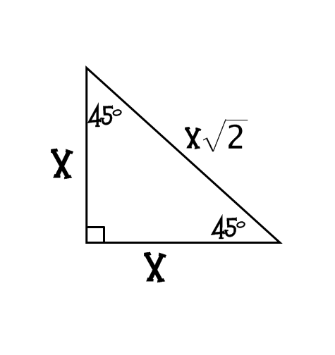

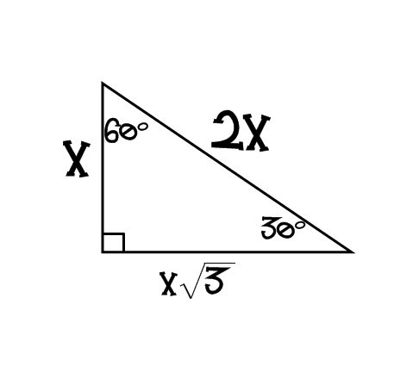

We are just going to look at just 30 – 60 – 90 today!!

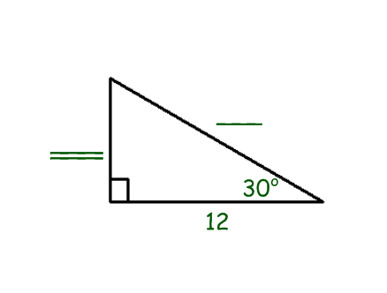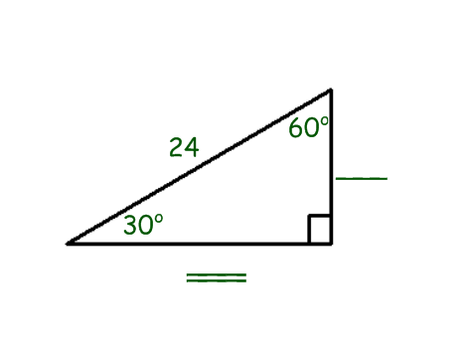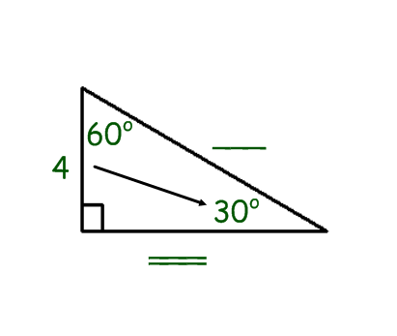

Examples

1. 2. 3.

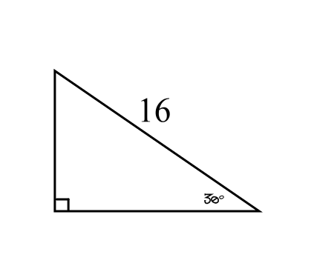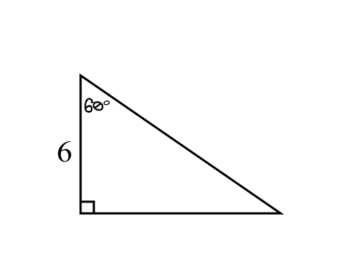

4. 5.

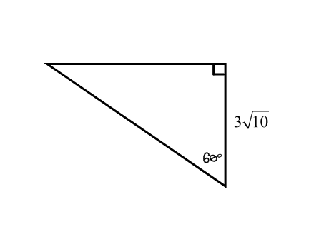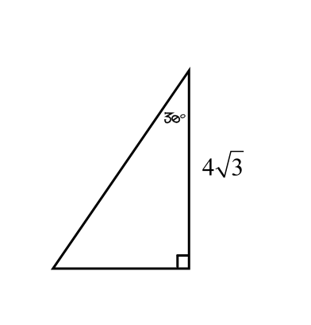

6. 7.

7. 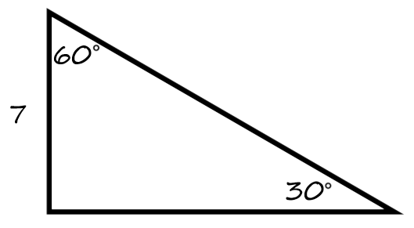 8. 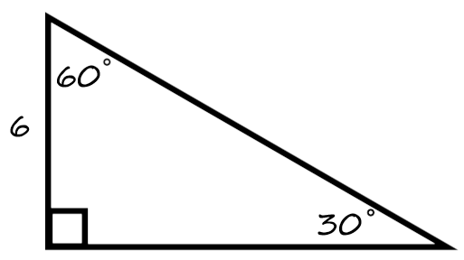

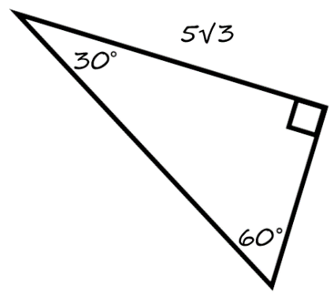9. 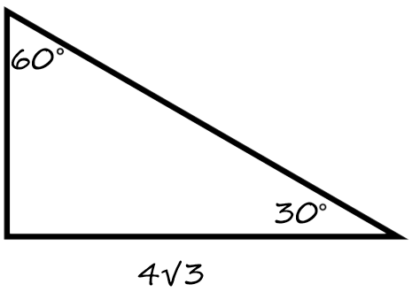 10.

11. 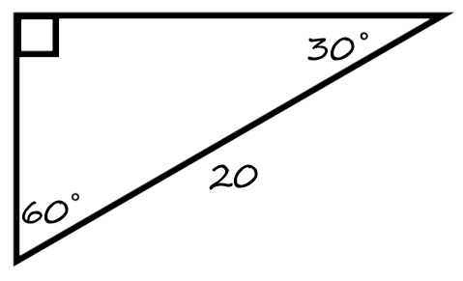 12. 