Geometry – Quiz Corrections – Unit 3 Triangle Congruence Name: _______________________________
Directions: Redo EVERY problem that you missed (with work shown & justification)!
Original Problem | Corrected Problem WITH WORK SHOWN | Justification
Example:  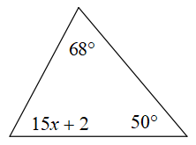  1. | 68 + 50 + 15x + 2 = 180  15x + 120 = 180  15x = 60  x = 4 | The sum of the interior angles of a triangle are equal to 180 degrees. So add up all of the angles and set them equal to 180. Then solve for x.
Original Problem | Corrected Problem WITH WORK SHOWN | Justification

