Write the correct vocabulary word next to the definition.

1. _____________________ - formed where two lines or rays share an endpoint
2. _____________________ - Part of a line bounded by two distinct endpoints
3. _____________________ - an exact position or location in a given plane
4. _____________________ - two lines that have unique points and never cross
5. _____________________ - a portion of a line that starts at a point and continues to infinity
6. _____________________ - the set of points on a plane at a certain distance, or radius from a single
point, the center
7. _____________________ - creates four right angles
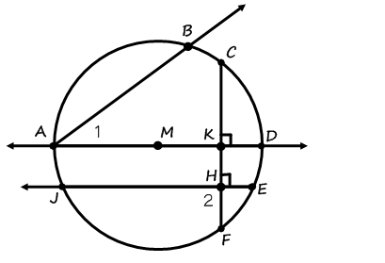
Find each geometry term in the diagram. Label using correct notation.

8. Ray: __________ 12. Circle: ___________

9. Line: ___________ 13. Line Segment: ___________

10. <1: ___________ 14. Parallel Lines: ___________

11. <2: ___________ 15. Perpendicular
Lines: ___________
16. Use the translation (x, y) (x – 4, y + 8) for questions a – d.
a. What is the translation vector? __________
b. What is the image of A (-5, -4)? __________
c. What is the image of A’’ (use part b)? __________
d. What is the pre-image of B’ (14, 8)? __________
Write the translation vector, line of reflection, or degree & direction of rotation for the following graphs.

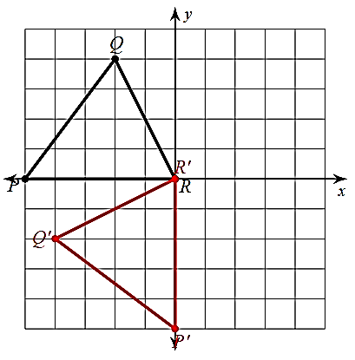
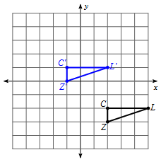
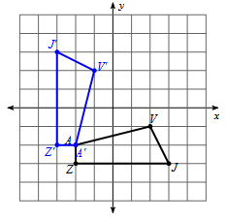
17. _________________ 18. _________________ 19. _________________

20. Write your rules for the following transformations:

a. Translation right h units and down k units: (x, y) __________________

b. Reflection over the x-axis: (x, y) __________________

c. Reflection over the y-axis: (x, y) __________________

d. Reflection over the line y = x: (x, y) __________________

e. Reflection over the line y = -x: (x, y) __________________

f. Rotation 90 degrees CW: (x, y) __________________

g. Rotation 90 degrees CCW: (x, y) __________________

h. Rotation 180 degrees: (x, y) __________________

21. The vertices of $∆$ABC are A(2, -4), B(0, 6), and C(-5, 3). Find the vertices of $∆$A’B’C’ given the transformation rules below. These describe the transformation that occurred.

- (x, y) (x – 8, y – 3) A’ = __________ , B’ = __________ , C’ = __________
Transformation: ______________________________

- (x, y) (x, -y) A’ = __________ , B’ = __________ , C’ = __________
Transformation: ______________________________

- (x, y) (-y, -x) A’ = __________ , B’ = __________ , C’ = __________
Transformation: ______________________________

- (x, y) (y, x) A’ = __________ , B’ = __________ , C’ = __________
Transformation: ______________________________

- (x, y) (-x, y) A’ = __________ , B’ = __________ , C’ = __________
Transformation: ______________________________

- (x, y) (y, -x) A’ = __________ , B’ = __________ , C’ = __________
Transformation: ______________________________
Follow the instructions for each graph.

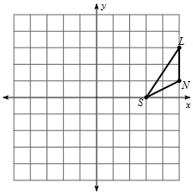
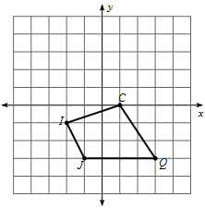
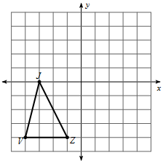
22. Reflection across y = -x. 23. Rule: (x, y) (x – 2, y + 4) 24. Reflection across y = -1.

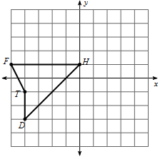
25. Reflection across x = -2. 26. Rotation 180 degrees 27. Rule: (x, y) (y, x)
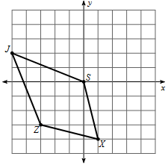
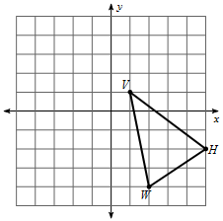

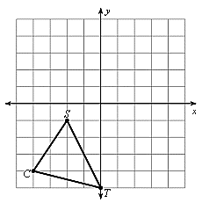
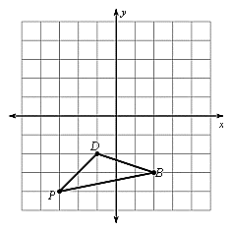
28. Rotation 90 degrees CW 29. 30. Rule: (x, y) (-x, y)
