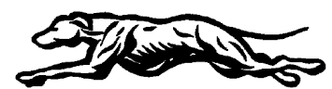
GEOMETRY
UNIT 11 AGENDA – Modeling in the Coordinate Plane Part 2 – 2020
*subject to change*
Monday  February 24 | Intro to Circle Equations
Tuesday  February 25 | Circle Equations & Proofs
Wednesday  February 26 | Parallel and Perpendicular Lines
Thursday  February 27 | Task Cards
Friday  February 28 | QUIZ – Cricle Equations & Parallel/Perpendicular Lines
Monday  March 2 | Coordinate Proofs – Rectangles & Squares
Tuesday  March 3 | Coordinate Proofs – Trapezoids & Triangles
Wednesday  March 4 | Practice Proofs
Thursday  March 5 | Test Review
Friday  March 6 | UNIT 11 TEST

